Digital Image Processing

Assignment 1 Report

Philani Mpofu (1848751)

14 April 2021

**Problem 1 - Low Light Image Contrast Enhancement**

* 1. **Contrast Stretching**

This section compares a set of input images and output images. The input images are the original image and the output images are the input images with a contrast stretching function applied to them. The function that was implemented was a modified version of the standard contrast stretching function with the added conditions:

1. , where r ≤ rmin
2. , where rmin < r < rmax
3. , where r ≥ rmax

rmin was selected as the pixel intensity value at the 1st percentile of the input image, and rmax was selected as the pixel intensity value at the 99th percentile of the input image. These specific values were selected, because they provided the best results for contrast stretching. Not using this modified version of the function results in little to no results on images 1 and 2, because the minimum intensity value in these images is 0 and the maximum intensity value is 255 which cancels out the L-1 term.

* + 1. **a. Image 1 Before and After Contrast Stretching:**

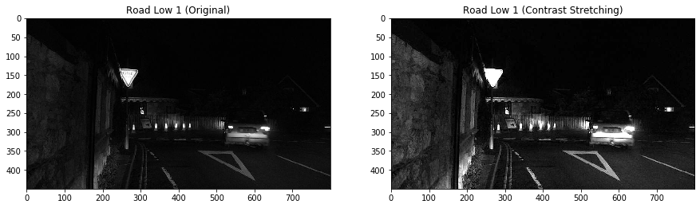

The original image is very dark and you can’t really see anything besides the car, the stop signs and the lights. After contrast stretching has been applied to the input image, the image is a lot clearer, brighter and one can make out more objects in this image than before contrast stretching was applied to it. You can see the house close to the right corner as well as the brick wall on the left side of the image. Furthermore, the bright intensity values of the input image, such as the lights, have been made more intense in the output image.

* + 1. **b. Histogram of Image 1 Before and After Contrast Stretching:**

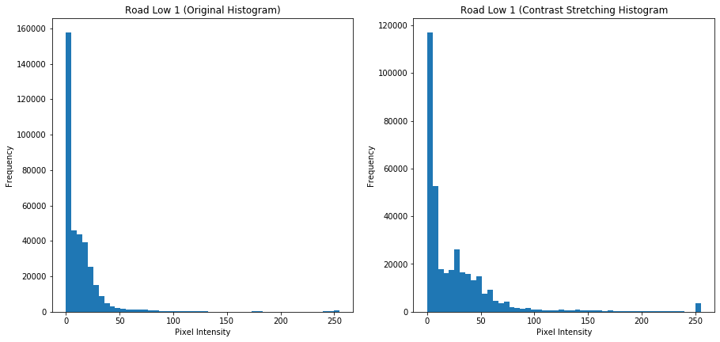

All the observations made in the subsection above can all be confirmed by looking at the histogram on the right. Although the distribution is still heavily concentrated between the 0th and 50th bins, this distribution is more 'spread out' than the one on the left.

* + 1. **a. Image 2 Before and After Contrast Stretching:**

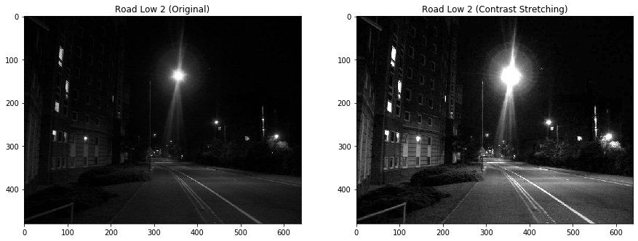

As in 1.1.1) After contrast stretching has been applied to the input image, the output image is a lot clearer and one can make out more objects in this image than before contrast stretching was applied to it. In addition, the brighter parts of the original image have been made even brighter and more intense after contrast stretching. For example, the house and streetlights are brighter in the image on the right than those of the image on the left. You can also make out finer details of the grass in the image on the left than the image on the right.

* + 1. **b. Histogram of Image 2 Before and After Contrast Stretching:**

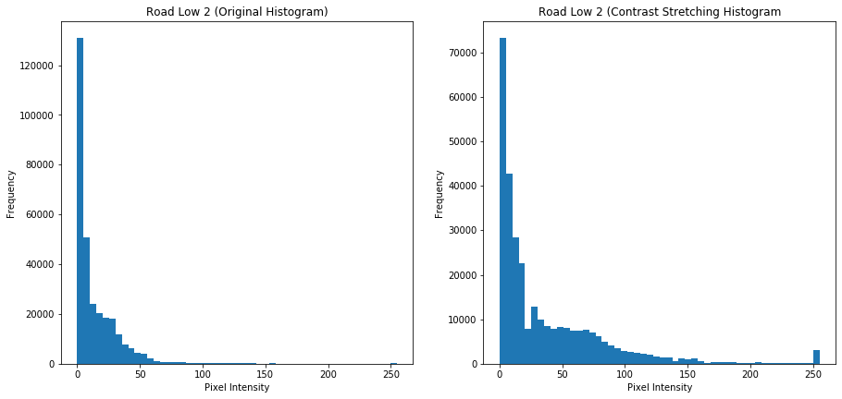

All the observations made in a) can be confirmed by looking at the histogram on the right. The original image is very dark, and the distribution of its histogram is heavily concentrated between the 0th and 50th bin. In the histogram on the right, the distribution is concentrated between the 0th and 25th bins. From about the 26th to about the 150th bin the distribution of pixel intensity values is more evenly distributed.

* + 1. 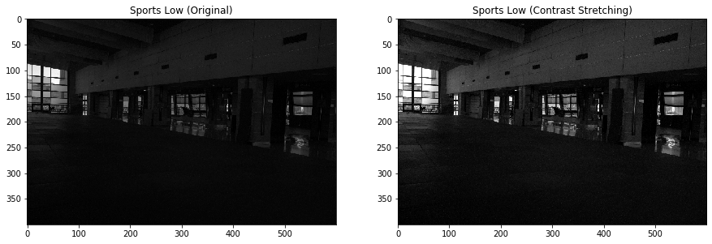**a. Image 3 Before and After Contrast Stretching:**

Similarly as in 1.1.1) and 1.1.2) The original image is very dark, and the distribution of its histogram is heavily concentrated between the 0th and 50th bin. After contrast stretching has been applied to it, the image is a lot clearer and one can make out more objects in this image than before contrast stretching was applied to it. After contrast stretching is applied on the image on the right you can make out how the light coming from outside illuminates the gymnasium, and you can better see the equipment in the building. Furthermore, you can make out the finer details of the floor pattern in the second image better than the one of the first image.

* + 1. **b. Histogram of Image 3 Before and After Contrast Stretching:**

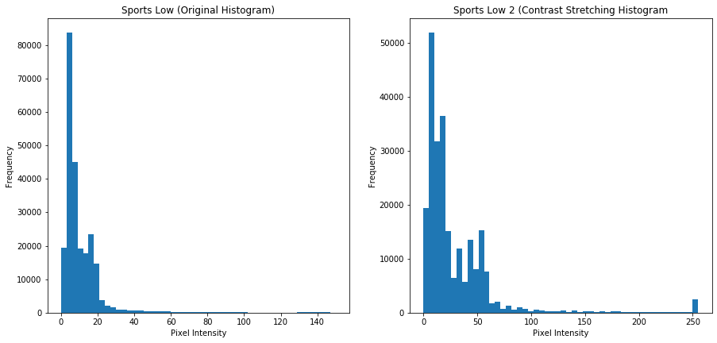

This can all be confirmed by looking at the histogram on the right. In this case, the distribution is heavily concentrated between the 0th and 25th bins. After bin the distribution of pixel intensity values is more evenly distributed. In other implementations one could maybe play around with the min max values to get a better stretching.

Thus, in all three cases the contrast function accomplished the goal it set out to accomplish which was to expand the range of intensity levels in an image so that it spans the ideal full intensity range of display device or recording medium.

* 1. **Histogram Equalization**

In this section, the standard histogram equalization function is applied to all three images to generate their respective output images and histograms.

**1.2.1) a. Image 1 with its Corresponding Histogram:**

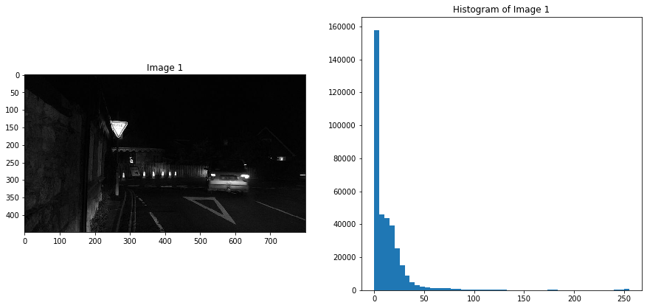

**1.2.1) b. The New Image 1 with its Corresponding Equalized Histogram:**

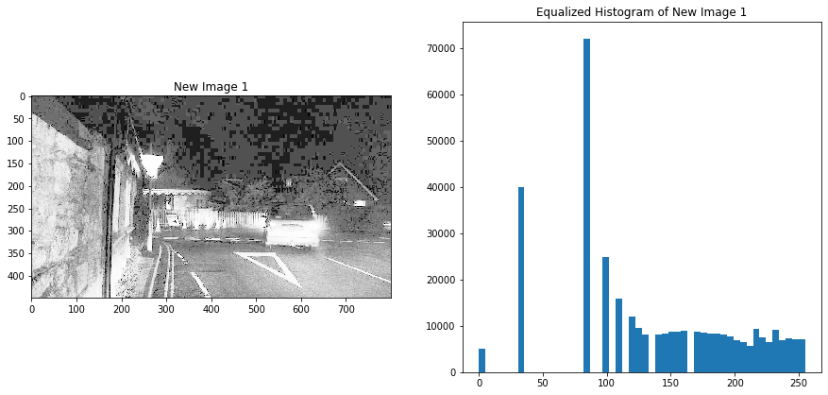

**1.2.2) a. Image 2 with its Corresponding Histogram:**

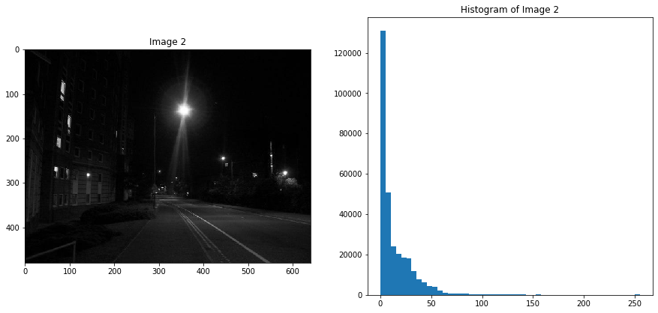

**1.2.2) b. The New Image 2 with its Corresponding Equalized Histogram:**

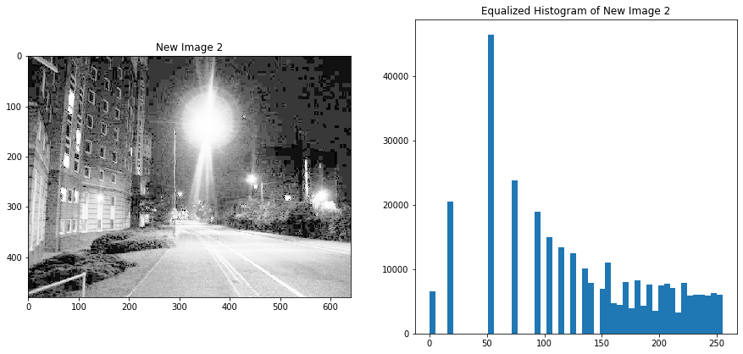

**1.2.3) a. Image 3 with its Corresponding Histogram:**

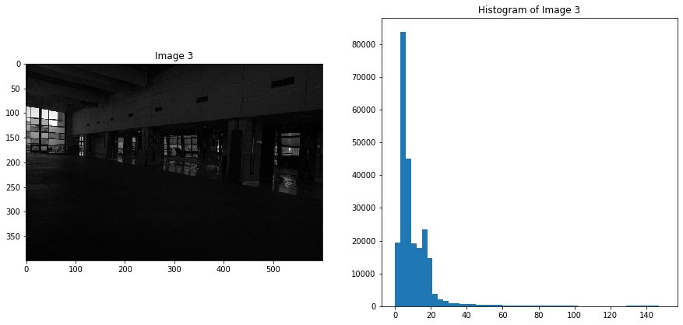

**1.2.3) b. The New Image 3 with its Corresponding Equalized Histogram:**

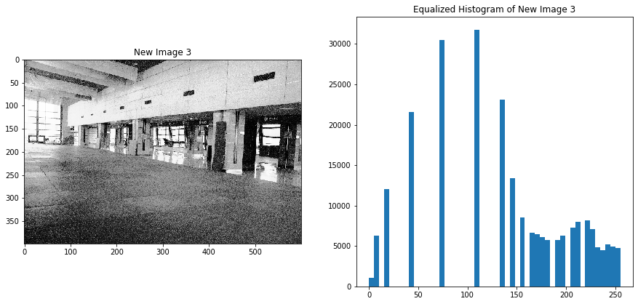

In all three cases the images, as well as their respective histograms were affected. This implies that the gray level values have all been made approximately equally likely (ie: all the levels of the histogram-equalized image span a fuller range of the gray scale). In addition, all of the histograms of the histogram-equalized images are more spread out than their respective input images.

**Problem 2 – Spatial and Frequency Domain Filtering**

**2.1 Filtering in the Frequency Domain**

**2.1.1) The Original Image with Lowpass Filtering (Frequency Domain):**

The Butterworth Lowpass filter function can be found in section 2.1.1 of the problem_2.ipynb. To generate this output D0 = 47 and n = 3. This function will be used to generate the highpass filer in the following section.

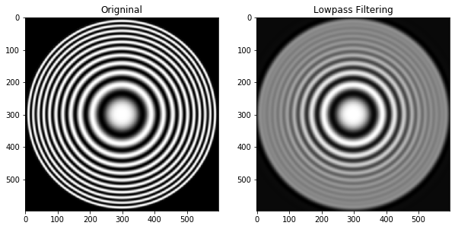

**2.1.2) The Original Image with Highpass Filtering (Frequency Domain):**

This output was generated by setting H = DFT * (1-(butterworth_lowpass()) with D0 = 93 and n = 3.

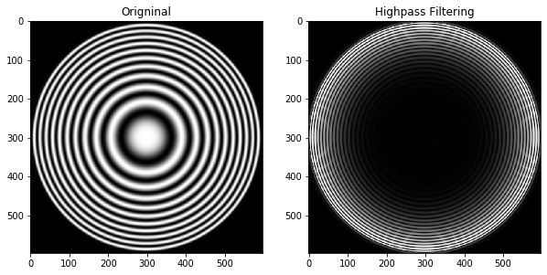

**2.1.3) The Original Image with Bandreject Filtering (Frequency Domain):**

The Butterworth Bandreject filter function can be found in section 2.1.3 of the problem_2.ipynb. To generate this output D0 = 50 and n = 3. This function will be used to generate the Bandpass filer in the following section.

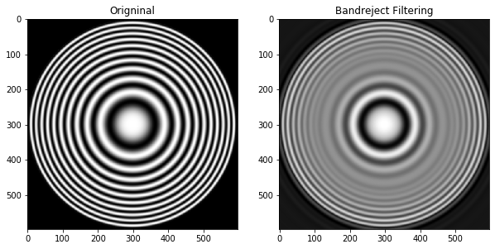

**2.1.4) The Original Image with Bandpass Filtering (Frequency Domain):**

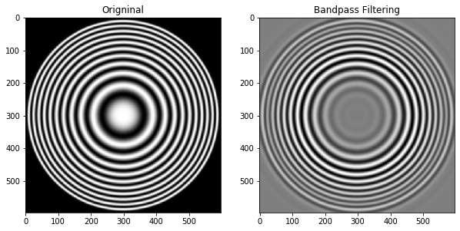This output was generated by setting H = DFT * (1-(butterworth_bandreject()) with D0 = 50 and n = 2.

**2.1.5) The Scaled Highpass and Bandpass Filter Images (Frequency Domain):**

The Scaled Highpass Filter image was generated by scaling the Highpass Filter image, and the Scaled Bandpass Filter image was generated by scaling the Bandpass Filter image.

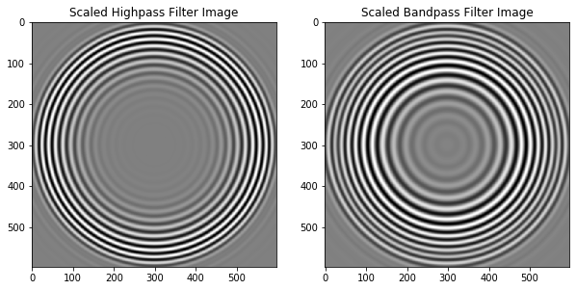

**2.2 Filtering in the Spatial Domain**

All output images within this section were generated using built-in functions in python which can be found in the problem_2.ipynb file.

**2.2.1) The Original Image with Lowpass Filtering (Spatial Domain):**

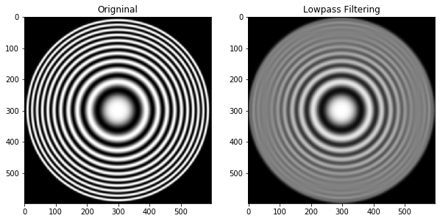

**2.2.2) The Original Image with Highpass Filtering (Spatial Domain):**

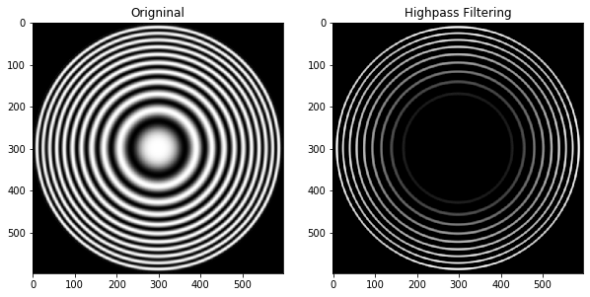

**2.2.3) The Original Image with Bandreject Filtering (Spatial Domain):**

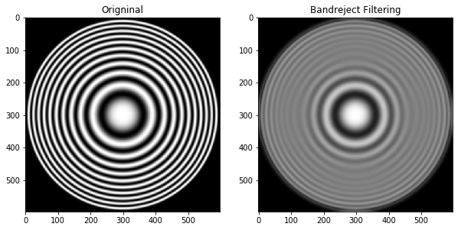

**2.2.3) The Original Image with Bandpass Filtering (Spatial Domain):**

